Flash unit

WHAT IS A SUPERHERO?
FRIEDRICH Delphine
Plp lettres-anglais Académie Amiens
EXERCISE: Read and comment the sentence below. Do you agree or not? Why?
_________________________________________________________________________________________________________________________________________________________________________________________________________________________________
EXERCICE : Vous devez remplir la mindmap ci-dessous (ou en réaliser une à l’aide d’un logiciel ou dans votre cahier.) Comme d’habitude, quand je vous donne un thème, vous devez noter ce qui vous vient en tête en essayant de catégoriser ! (un exemple : les pouvoirs). Vous pouvez bien sûr faire plus de 4 branches !

Create a mindmap:

SUPERHEROES

Superpower

Exercise: In the following pages, you’ll find:
- Peoples’ descriptions
- Photographs
- Names
J’ai numéroté les personnages. Chaque description et photo contient un encart pour y écrire le numéro.
Dans un premier temps, servez-vous de vos connaissances pour trouver de qui il s’agit.
Ensuite vous pouvez demander à vos parents/ proches.
En dernier lieu, faites des recherches sur Internet.

WHO IS SHE?

She achieved international celebrity status as the first woman to cross the Atlantic Ocean in an airplane. While her achievement as an aviator is legendary, her commitment to women’s rights is less well-known. She told the story of her remarkable life and career, emphasizing on her role in breaking barriers for women.

Who am I?

I am called the Amazon Princess. I am a powerful, strong-willed character who doesn’t back down from a fight or a challenge. I am a lover of peace who would never seek to fight or escalate a conflict. I am both the most fierce and most nurturing member of the Justice League. I was particularly acclaimed by Lady Diana.

What’s my name?

I am a Jamaican sprinter. I won gold medals in the 100 metres and the 200 metres three time in a row. I am widely considered to be the greatest sprinter of all time.

He was an English musician, singer and songwriter who rose to worldwide fame as a founding member of The Beatles. Who is he?

Find out what are his name and surname:

He was an English physicist and mathematician. He is widely regarded as one of the most influential scientists of all time and as a key figure on the scientific revolution.

He was an English poet and playwright, widely regarded as the greatest writer in the English language. Who is he?

What a woman! But who is she?

She was called the “Mother of the modern-day American civil rights movement” and “Mother of the freedom movement”. She refused to move to the back of the bus so a white passenger could take her seat in the front of the bus.

He is a comic character and probably the first powerful superhero in fiction. The character was created by writer Jerry Siegel and artist Joe Shuster in Cleveland, Ohio, in 1933. What’s his name?

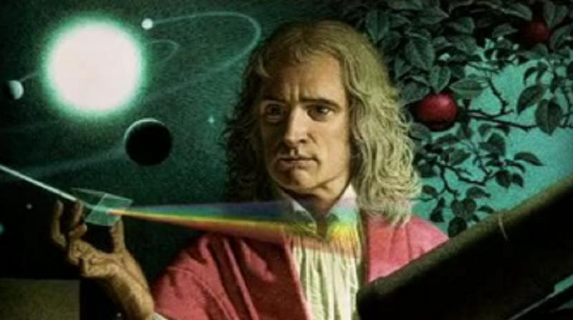

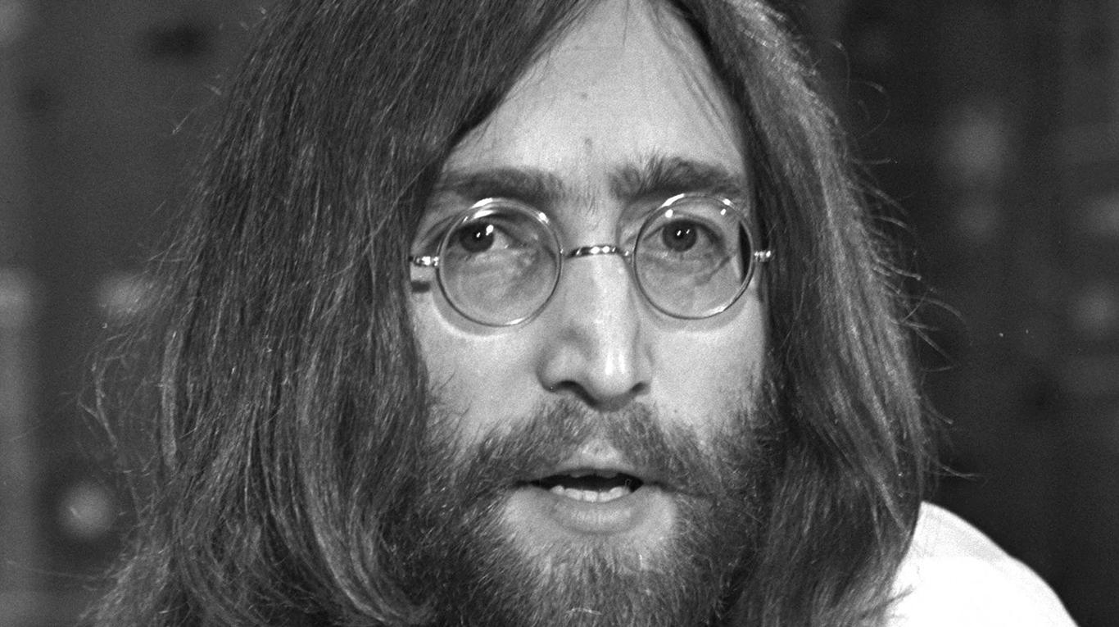

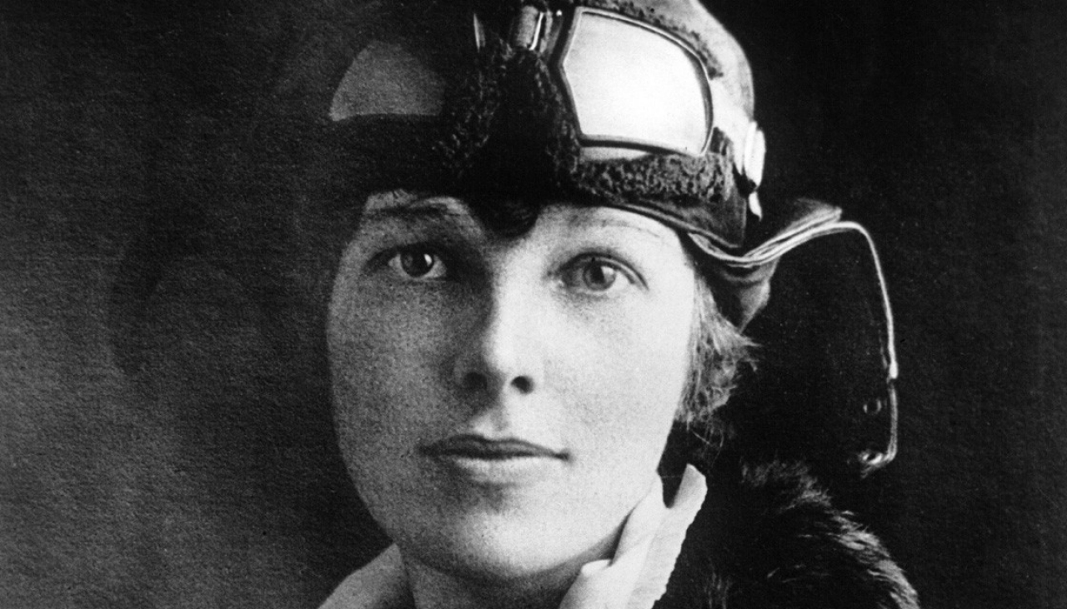

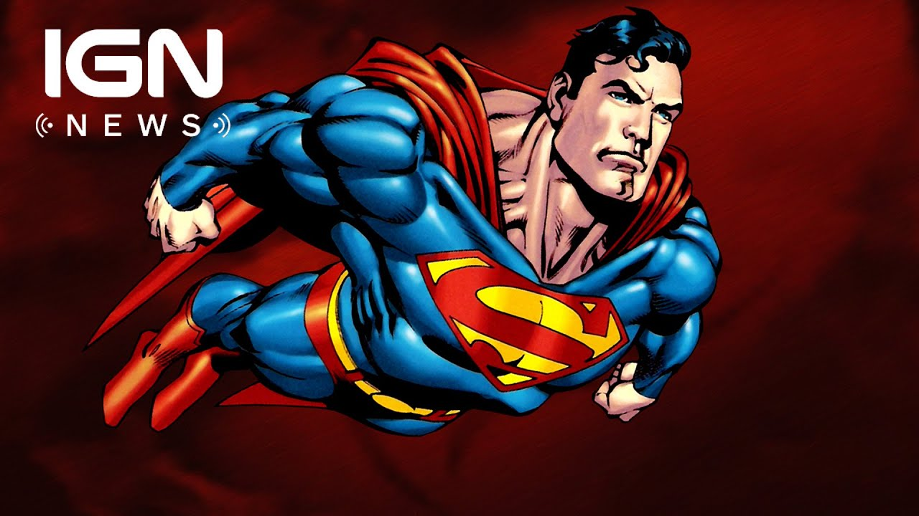

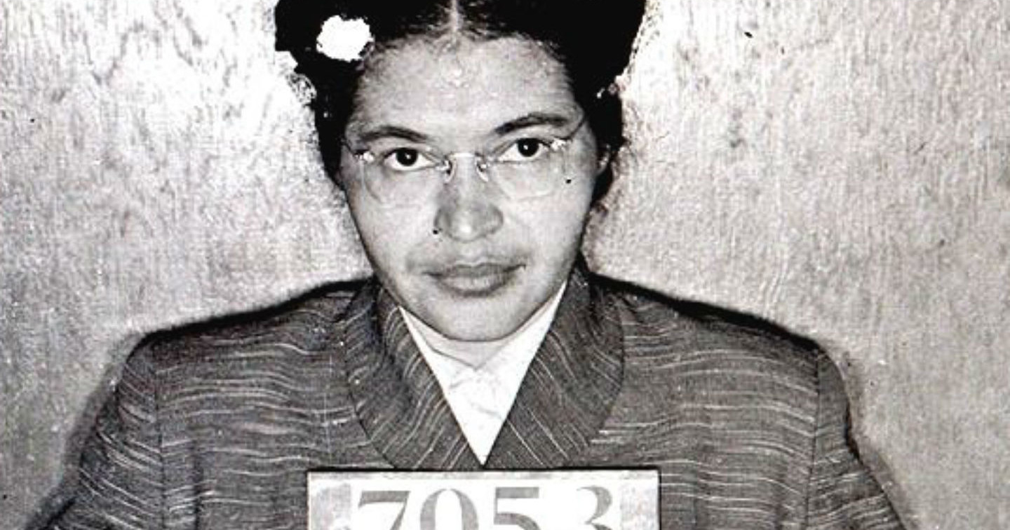

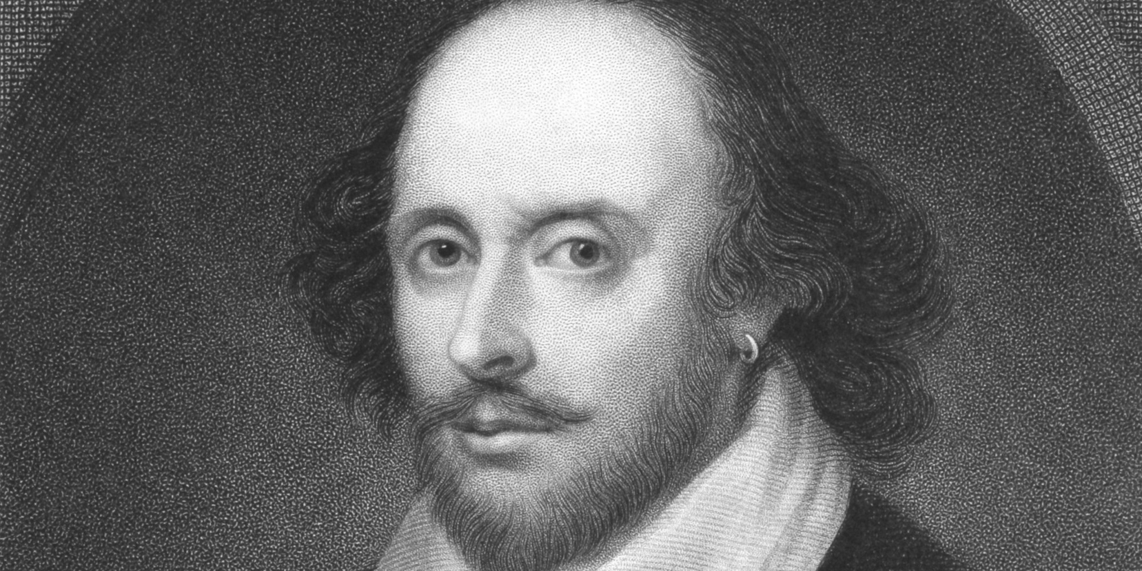

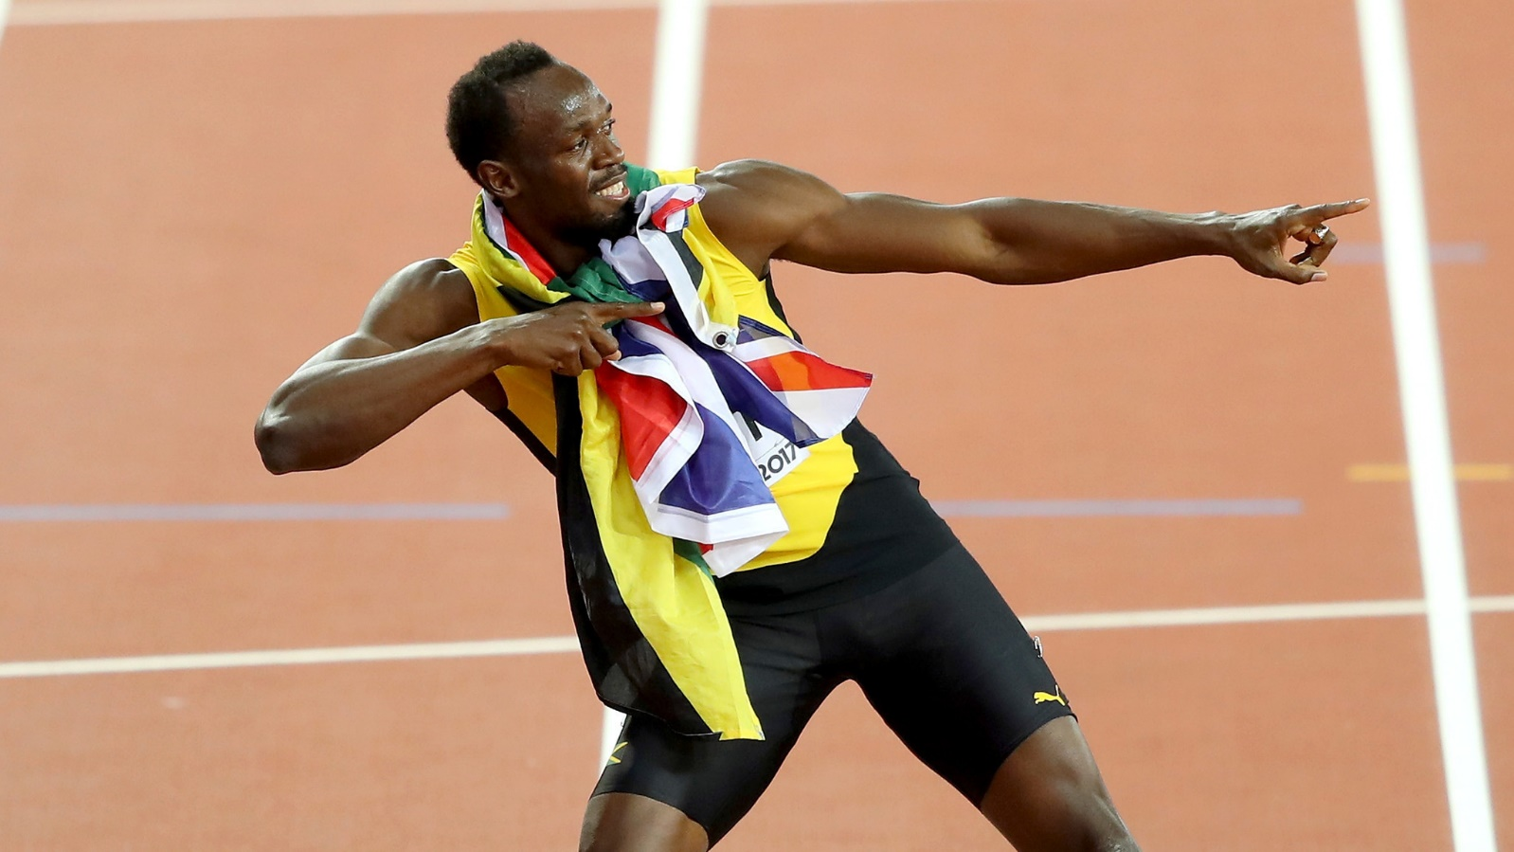

1Ussain Bolt 2 John Lennon

3Amelia Earhart 4Isaac Newton

5Wonder Woman 6Rosa Parks

7Shakespeare 8Superman

EXERCICE: (Ecrivez directement dans le tableau)
Name the fictional heroes and the factual (real) heroes (using the photographs above):
Fictional | Factual
Explain the domain they belong to* (*appartenir): EX: sport number 1 Ussain Bolt
_ _
_ _
_ _
_ _
EXERCISE : What is, according to you, a hero? Who is your hero and explain why. (l’exercice se fait en trois temps. TA définition d’un héros, qui est ton héros et pourquoi ?)
Pensez à utiliser la fiche « donner son avis, exprimer son opinion » To my mind, in my opinion … I believe, I think …
A hero is someone who __________________________________
------------------------------------------------------------------------------------------------------------------------------------------------------------------------------------------------------------------------------------------------------------------------------------------------------------------------------------------------------------------------------------------------------------------------
----------------------------------------------------------------------------------------------------------------------------------------

Comprehension ecrite :
The real STORIES of the superheroes
By Dulce Pinzon
After September 11, the notion of “hero” began to rear its head in the public consciousness more and more frequently. The notion served a necessity in a time of national and global crisis to acknowledge those who showed extraordinary courage or determination in the face of danger.
The Mexican immigrant worker in New York is a perfect example of the hero who has gone unnoticed. It is common for a Mexican worker in New York to work extraordinary hours in extreme conditions for very low wages which are saved at great cost and sacrifice and sent to families and communities in Mexico who rely on them to survive.
The Mexican economy has quietly become dependent on the money sent from workers in the US. Conversely, the US economy has quietly become dependent on the labor of Mexican immigrants.
The principal objective of this series is to pay homage to these brave and determined men and women that somehow manage, without the help of any supernatural power, to withstand extreme condition of labor in order to help their families and communities survive and prosper.
This project consists of 20 color photographs of Mexican immigrants dressed in the costumes of popular American and Mexican superheroes. Each photo pictures the worker/superhero in their work environment.
Adapted from the article http://www:dulcepinzon.com/en_projects_superhero.htm
EXERCICE: Répondez aux questions EN FRANÇAIS
Quel est le sujet du document ?
----------------------------------------------------------------------------------------------------------------------------------------
Trouver un titre à chaque paragraphe
--------------------------------- ---------------------------
--------------------------------- ------------------------------------------------------------ ---------------------------
Quelle est la « problématique », l’enjeu du document ?
--------------------------------------------------------------------------------------------------------------------------------------------------------------------------------------------------------------------------------------------------------------------------------
Quel est, selon vous, le but de cette exposition ?
------------------------------------------------------------------------------------------------------------------------------------------------------------------------------------------------------------
Citez d’autres exemples de « héros » que ceux mentionnés dans le document ?
--------------------------------------------------------------------------------------------------------------------------------------------------------------------------------------------------------------------------------------------------------------------------------

Expression écrite :
- Chose one photograph among the following (there are 7 photographs).
- Describe it and
- Write a little commentary (what is behind the photograph / the message).
Help: begin with the man or the woman’s job / link the text yout just read with the photograph.

